Install and Configuration for Barracuda NG Firewall Daily Config Change Report

Set up the daily config report on your NG Firewall by installing the report scripts and cleanup script on the firewall and configuring the NG Firewall to use RCS reporting. Be sure that the script files are located on an accessible folder on your Windows file system. Note that you will also need to enable SSH access in the NG Firewall in order to install the scripts.

Step 1: Configure NG Firewall

In NGAdmin, go to CONFIGURATION > Configuration Tree > Administrative Settings > RCS Setup

Click “Lock.” Set “Version Control System” to “Enable” and set “Log Change Differences” to “Log-File-and-Report.” Set “Log Creation Differences to “None” and set “Log Removal Differences” to “Full-Info.” Optionally you can set “Force RCS Change Message” to “Yes” to require a change message to be supplied with each configuration update. The updated RCS settings look like this:

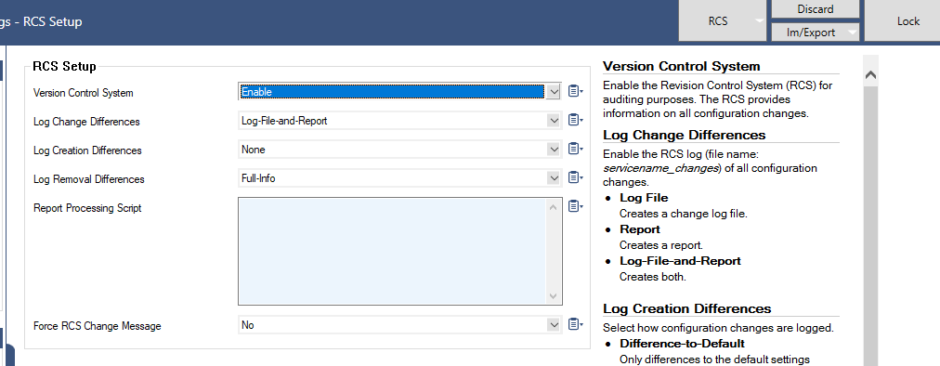

Click “Send Changes” and “Activate” and “Activate” again.

The NG Firewall will now create a log file each time a configuration change is made.

Step 2: Install Scripts

Download the scripts from the [github repo](https://github.com/mercutioviz/ngf-config-report) and place into a local folder on your computer. In NGAdmin, go to the SSH tab and log in as root. Once logged in, perform the following commands:

cd /usr/local/bin

Click “Send File” and select the report file “format-rcs-report.pl”

Click “Send File” and select the cleanup file “rcs-cleanup.sh”

chmod +x format-rcs-report.pl

chmod +x rcs-cleanup.sh

cd /etc/cron.daily

Click “Send File” and select the report file “send-config-report.sh”

chmod +x send-config-report.sh

cd /etc/cron.monthly

ln -s /usr/local/bin/rcs-cleanup.sh ./rcs-cleanup.sh

The system is now prepared to send reports. You may manually create report for a given date by running the format-rcs-report.pl script with the --date argument. Example:

format-rcs-report.pl --date=”2018-03-30”

Output goes to console by default. You may also redirect to a text file and then email manually:

format-rcs-report.pl --date=”2018-03-30” > /tmp/report.txt

/opt/phion/bin/mailclt -f sender@email -r recipient@email -m x.x.x.x \

-s "Config Report" -a /tmp/ report.txt

Be sure to use valid sender address, recipient address and SMTP server IP address.